Informational letter 1
Russian Academy of Sciences
Federal Agency for Scientific Organizations
State Space Corporation ROSCOSMOS
Russian Federation State Scientific Center - Institute of Biomedical Problems,
Russian Academy of Sciences
Research and Test Center of Aerospace Medicine and Military Ergonomics of Air Force CRI,
Russian Ministry of Defense
I.P.Pavlov's Physiological Society
Union of the Physiological Societies in CIS Countries

Scientific Forum Dedicated to the 100 ^{th} Birthday of Academician
O.G. Gazenko
/XVII Conference on Space Biology and Aerospace Medicine with International Participation/

The conference will be held December 10 -12, 2018 in the meeting rooms of the Presidium of the Russian Academy of Sciences (Leninsky prospect 32A, Moscow)
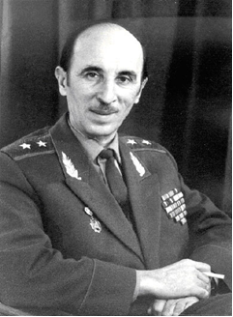
Working languages - Russian, English

Oleg Georgievich Gazenko /12.12.1918 - 17.11.2007/
O.G. Gazenko - lieutenant- general of Medical Corps, active member of the Russian Academy of Sciences, outstanding scholar and science manager, one of the founders of space biology and medicine, winner of numerous prestigious national and international awards.

Plenary session
O.G. Gazenko's contribution to general physiology, space biology and physiology, aerospace medicine and international scientific cooperation
Topics of symposia and sections
Motion sickness and spatial orientation
Motor disorders
Orthostatic instability
Prevention of structural and functional disorders
Artificial gravity
Gravitational cell biology
Biological life support systems
Human factor in aviation and space flights
Analog studies
Toxicological and microbiological safety of long-term stay in enclosed environments
Physiological effects of extreme physical factors
Human protection in aviation and space flights
Radiation safety
On-line registration, payment of the registration fees and additional information about the Conference will be available on Conference site www.spacemedicine-2018.com or IBMP site www.imbp.ru beginning March 15, 2018.
Deadline for abstracts - June 8, 2018
Organizing Committee Points of Contact
Logistics issues:
Romanov Aleksander N. (+7) 499 195 02 03
Ponomarev Sergei A. (+7) 499 195 65 26, (+7) 903 204 91 75; e-mail: cd147@bk.ru

Organization committee

