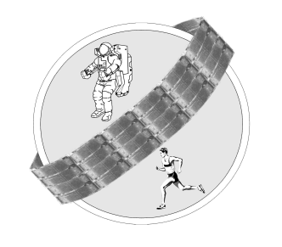
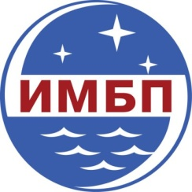


Information letter

Dear colleagues!

Russian Federation State Research Center – Institute of Biomedical Problems, Russian Academy of Science and Faculty of Basic Medicine, Lomonosov Moscow State University would like to invite you to participate in the work of the IX Russian National School/Conference with International Participation on Muscle and Exercise Physiology «New approaches to investigation of classical problems» dedicated to the memory of E.E. Nikolsky.
School meetings will be held at the SSC RF – IBMP RAS (76a Khoroshevskoye shosse, Moscow) on March 18-20, 2019.
School program includes the plenary sessions and the symposiums on the following problems:
• Future technologies in neurorehabilitology
• Contractile functions of the muscle and its neural control (dedicated to G.A. Nasledov)
• Molecular and Physiological mechanisms of adaptation to contractile activity.

The program of the School includes presentations of the leading experts in physiology, cell physiology, biochemistry and rehabilitology.
In the school framework the presentation of free papers in oral or poster forms (15-20 or 5 minutes, respectively, for the report and discussion) will take place, the competition of posters authored by young scientists (younger than 35) will be organized. The authors of the selected papers will present their posters as short communications (5 min for report and discussion).
Abstracts of the reports will be published.
The scientists, lecturers, tutors, postgraduate students, interns and students are invited to take part in School on Muscle and Exercise Physiology «New approaches to investigation of classical problems».
Sessions and workshop program based on abstracts received will include lectures, oral and poster presentations.
The deadline for abstract submission is December 15th, 2018.
Please, fill in the application and abstract form on the website of the conference: http://mep.imbp.ru
The number of authors should not exceed 5 persons from 3 not more than organizations. Abstract is restricted to 1500 characters including spaces (without title, authors and organization).
Poster size is A1 (90X60 cm); format is portrait.
The delivery of your abstract will be confirmed by e-mail.
Registration fee for participants is 1000 rubles (for students and postgraduates - 500 rubles).
The organizing committee asks your assistance in distribution of information on School/Conference among your colleagues.
If you have questions or problems with on-line registration please contact the secretariat by e-mail mep.imbp@gmail.com. Fill the field “subject” with the note “School2019”. Letters without such mark won't be open and, in order to avoid PC infection with viruses, will be deleted.
All the information on the School will be placed on its official website
http://mep.imbp.ru

The Organizing Committee puts forward hotel accommodation options, suggesting early hotel reservation (November-December). You may find three star hotels at the site http://www.moskva4you.ru. Tel. +7 495 768 38 42

Inesa B. Kozlovskaya 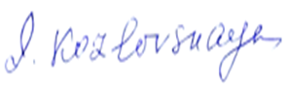
M.D., D.Sci., Prof.
Head of Department of
Sensorimotor Physiology and Countermeasures
SRC RF IBMP RAS,
76a, Khoroshevskoe shosse,
123007 Moscow, Russia

